**CLOUD COMPUTING  
Practical 6: Installing UBUNTU AND WINDOWS using VMWARE**

**Name: Indrayani Shinde**

**Roll no. A065**

**Step 1:** Click on the link provided below. Now select the version you want to download and click on “Go to downloads”. [https://customerconnect.vmware.com/en/downloads/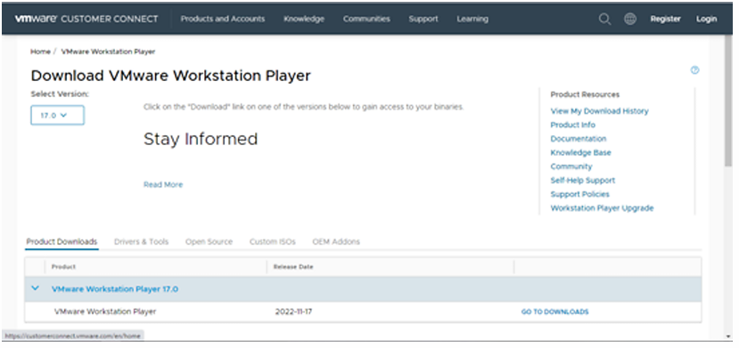](https://customerconnect.vmware.com/en/downloads/)

**Step 2:** Now, Click on download now

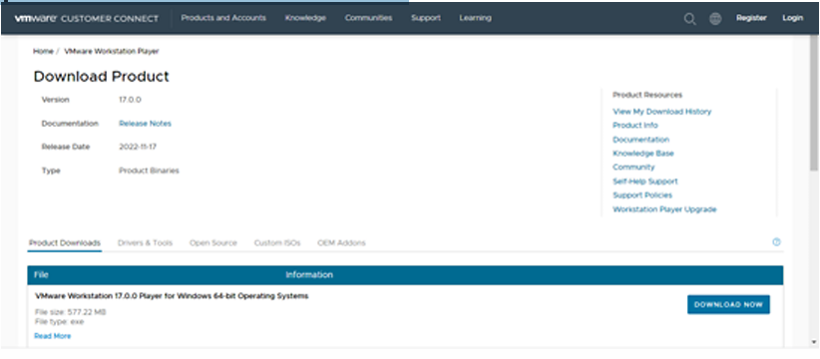

**Step 3:** Open the (.exe) file and install it.

**Step 4:** Open the link below and download the Ubuntu ISO file. <https://ubuntu.com/download/desktop>

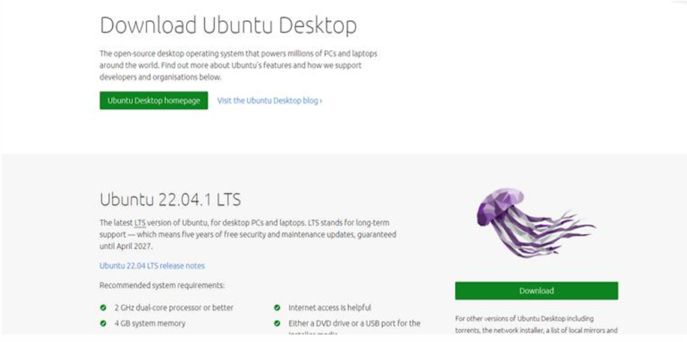

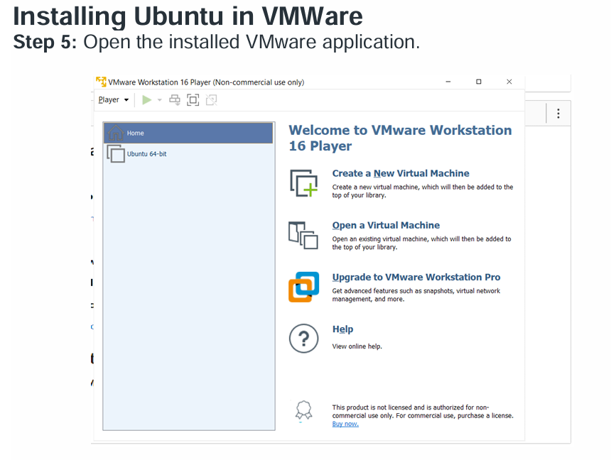

**Step 6:** Click on “Create new virtual machine”. Browse the ISO file that has been downloaded and select it.

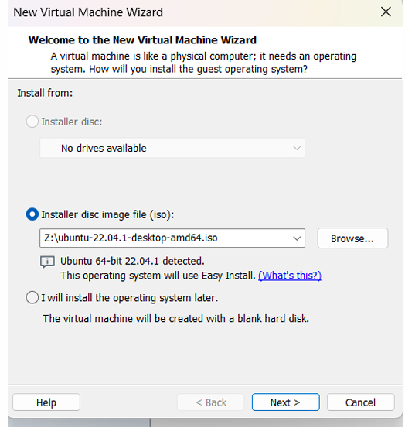

**Step 7:** Enter all the details >> click on next. Personalization of Virtual Machine.

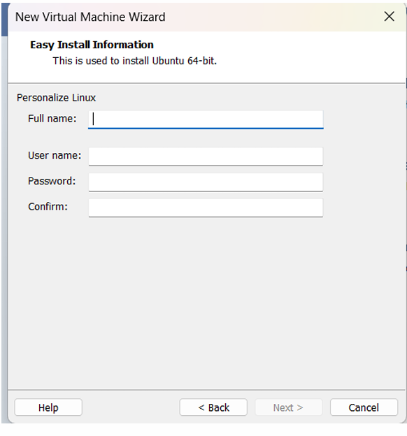

Step 8: Enter Virtual machine name >> click on next.

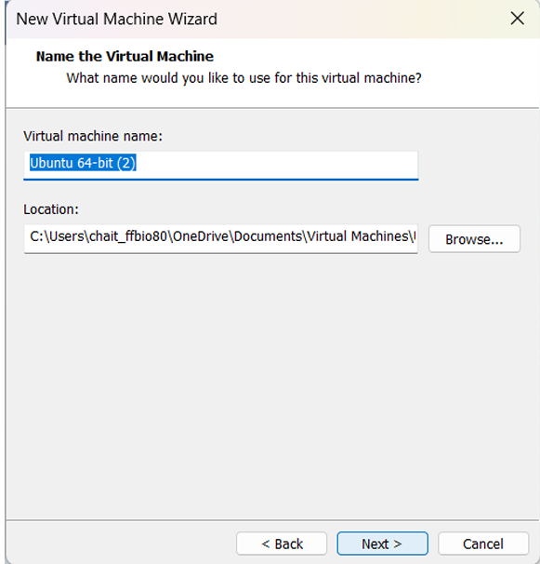

**Step 9:** Specify disk capacity >> click on next.

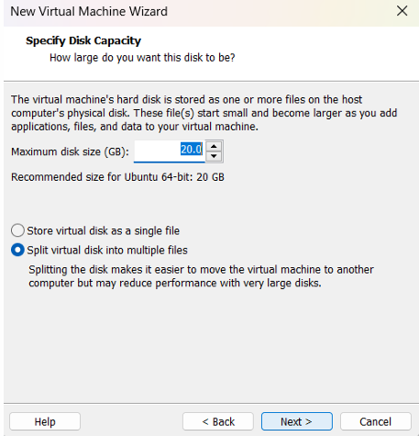

**Step 10:** If needed customize the hardware and click on finish

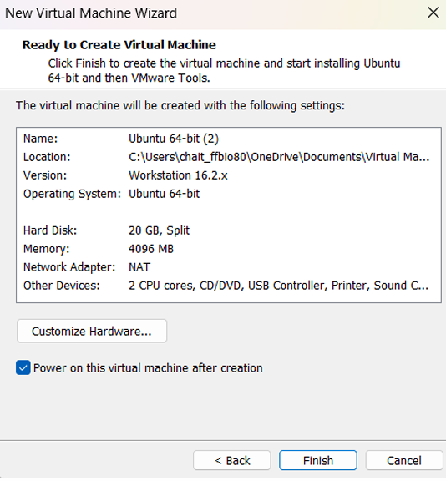

**Step 11:** Ubuntu has been successfully installed in VMWare. Now open VMware and click on ubuntu-64 which appears on the left panel. (If not directly opened). Select the language and click on next. Select the Normal or Minimal installation based on your requirements.

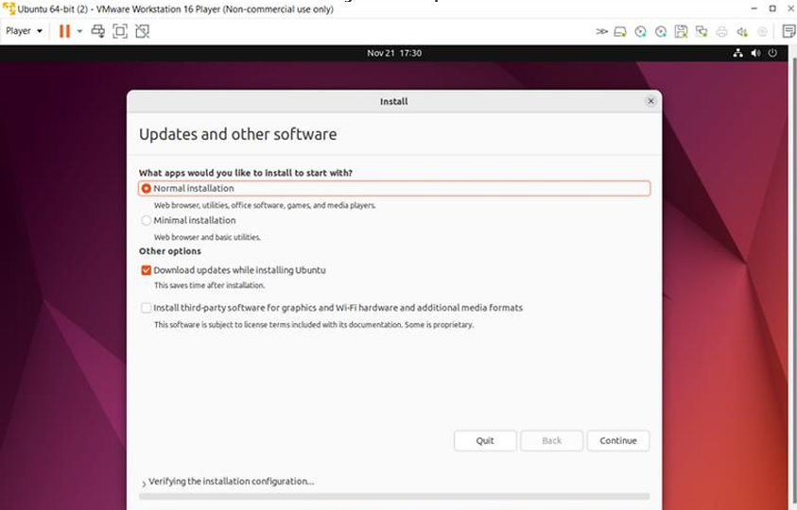

**Step 12:** Select Installation type >> Erase disk and install Ubuntu (This will not delete your windows data) >> Click on install now.

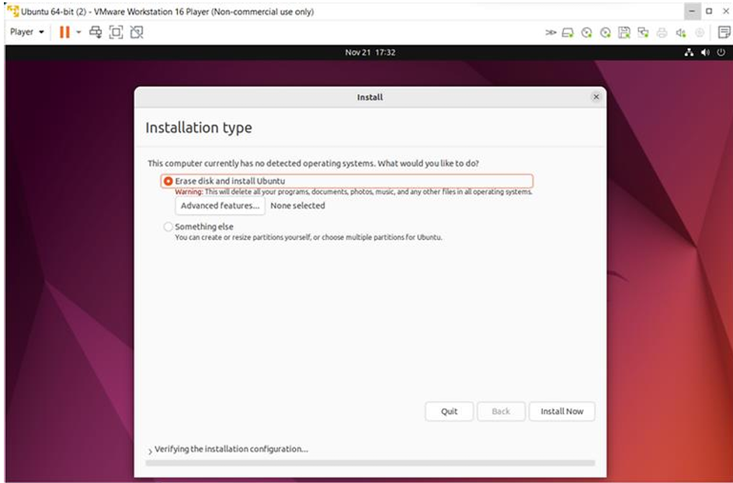

Installing Windows in VMWare

**Step 13:** Similarly for windows just **install windows 7 in place of Ubuntu (repeat steps from 5th step)**